**FINANCE / BANK LOAN REPORT SQL QUERY DOC**

**KPI’s:**

Loan Applications:

____________________________________________________________

Total Loan Application

select distinct count(id) as Total_Loan_Application from finance_loan



MTD Loan application

select count(id) as MTD_Loan_Appoliaction from finance_loan

where month(issue_date) = 12

Number of loan applications Monthly i.e., MTD Loan Application

select date_format(issue_date,"%M") as Months, count(*) as MTD_Loan_Application from finance_loan group by Months order by MTD_Loan_Application

___________________________________________________________

Loan Amount Funded:

____________________________________________________________

Total Amount Funded as Laon

select sum(loan_amount) as Total_Fund_Amount from finance_loan;



MTD Amount Funded

select sum(loan_amount) as MTD_Total_Fund_Amount from finance_loan

where month(issue_date) = 12



Total amount funded in each month

select date_format(issue_date,"%m") as month_num, sum(loan_amount) as MTD_Total_Funded_Amount from finance_loan

group by month_num order by month_num

Loan Payment Received:

____________________________________________________________

Total Payment received from borrower.

select sum(total_payment) as Total_Payment_Recieved from finance_loan;

current MTD Payment received.

select sum(total_payment) as MTD_Total_Payment_Recieved from finance_loan

where month(issue_date) = 12



Total amount received in each month based on the date the loan application was issued.

select date_format(issue_date,"%m") as month_num, sum(total_payment) as MTD_Total_Payment_Recieved from finance_loan

group by month_num

order by month_num;

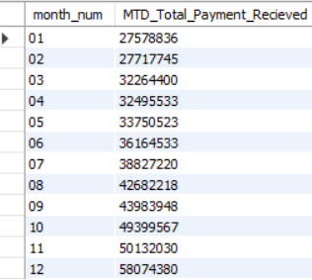

____________________________________________________________

Average Interest Rate/DTI:

____________________________________________________________

Fetch min interest rate, max interest rate, Average interest rate %

select round(min(int_rate) *100,2) Minimum_interest_rate, round(max(int_rate)*100,2) as Maximum_interest_rate,

round(avg(int_rate) *100,2) as Average_interest_rate from finance_loan;



current MTD Average Interest

select round(avg(int_rate)*100,2) as MTD_Average_interest_rate from finance_loan

where month(issue_date) = 12



-- PMTD Average Interest

select round(avg(int_rate) *100,2) as PMTD_Average_interest_rate from finance_loan

where month(issue_date) = 11



DTI:

-- Fetch min dti, max dti, Average dti in given set

select round(min(dti),4) debt_income_ratio, round(max(dti),4) as debt_income_ratio,

round(avg(dti),4) as debt_income_ratio from finance_loan



current MTD Average DTI

select round(avg(dti),4) MTD_debt_income_ratio from finance_loan

where month(issue_date) = 12;



PMTD Average DTI

select round(avg(dti),4) PMTD_debt_income_ratio from finance_loan

where month(issue_date) = 11

____________________________________________________________

**NOTE: - A good loan is a loan where the borrower consistently meets the payment obligations, whereas the bad loan is a loan where borrowers struggle to make payment one time.**

Good Loan:

Count of good loan application and Percentage of good loan application

SELECT (COUNT (CASE WHEN loan_status = "Fully Paid" OR loan_status = "Current" THEN id END) * 100) / COUNT (id)

AS good_loan_percentage FROM finance_loan;



select count(id) as count_good_loan_application from finance_loan

where loan_status="fully paid" or loan_status="current"

Total Good loan amount funded by lender

select sum(loan_amount) as Good_Loan_Amount_Funded from finance_loan

where loan_status="fully paid" or loan_status="current"

Total Good loan payment recieved from borrower

select sum(total_payment) as Good_Loan_Payment_Recieved from finance_loan

where loan_status="fully paid" or loan_status="current";



Bad Loan:

Count of bad loan application and Percentage of bad loan application

SELECT (COUNT (CASE WHEN loan_status = "charged off" THEN id END) * 100) / COUNT(id)

AS bad_loan_percentage FROM finance_loan;



select count(id) as count_bad_loan_application from finance_loan

where loan_status in ("charged off");

Total Bad loan amount funded by lender

select sum(loan_amount) as Bad_Loan_Amount_Funded from finance_loan

where loan_status="charged off”



Total Bad loan payment received from borrower.

select sum(total_payment) as Bad_Loan_Payment_Recieved from finance_loan

where loan_status="charged off”

count of application, Amount by lender, Payment Received based on Loan status with Avg interest rate % and Avg DTI %

select loan_status,count(id) as Loan_Application, round(Avg(int_rate)*100,4) as Avg_Interest_Rate, round (Avg(dti)*100,4) as Avg_dti_rate, Sum(loan_amount) as Amount_Funded, sum(total_payment) as Payment_Recieved from finance_loan

group by loan_status;

Bank Loan report overview based on purpose.

select purpose, round(avg(int_rate) *100,2) as Avg_Interest_Rate,

round(avg(dti)*100,2) as Avg_Dti_Rate, count(id) as Loan_Application,

sum(loan_amount) as Amount_Funded, sum(total_payment) as payment_Recieved

from finance_loan

(NOTE: -**add where condition; like where grade="A1" etc.**)

group by purpose

Bank Loan report overview based on home ownership.

select home_ownership, round(avg(int_rate) *100,2) as Avg_Interest_Rate,

round(avg(dti)*100,2) as Avg_Dti_Rate, count(id) as Loan_Application,

sum(loan_amount) as Amount_Funded, sum(total_payment) as payment_Recieved

from finance_loan

group by home_ownership

Bank Loan report overview based on Employee Job lenght

select emp_length, count(id) as Loan_Application,

sum(loan_amount) as Amount_Funded, sum(total_payment) as payment_Recieved

from finance_loan

group by emp_length

order by emp_length

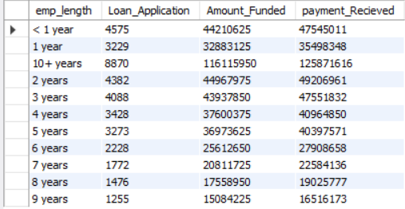

Loan status metric: -

(We can switch to other values of loan status in same query

we can add where condition also to filter result based on purpose etc.)

select count(id) as Total_Loan_Application,

count (case when loan_status= 'charged off' then id end) as Total_Chargedoff_Application, (count (case when loan_status= 'charged off' then id end) *100) /count(id) as Total_Chargedoff_Application_Percent

from finance_loan



Bank Loan report overview-based on state: -

select address_state, round(avg(dti)*100,2) as Avg_Dti_Rate, count(id) as Loan_Application, sum(loan_amount) as Amount_Funded, sum(total_payment)as payment_Recieved

from finance_loan

(can also add where condition like; where home_ownership="Rent")

group by address_state



